PRODUCT FILTER NETWORK CONFIGURATION FOR REMOTE CONNECTIVITY
- Navigate to the Service Desktop -> Utilities -> Product Network Filter (PNF)
- If the Firewall Filter is turn off changes are not necessary but recommended in case it gets turned on in the future.
- Under the Named Services make sure they are active or add the services ping, telnet, vnc, rlogin, ftp, and ssh for the coldtrac ip address.
NOTE: some of the services might already be enabled for all IPs and there is no need to add them then.
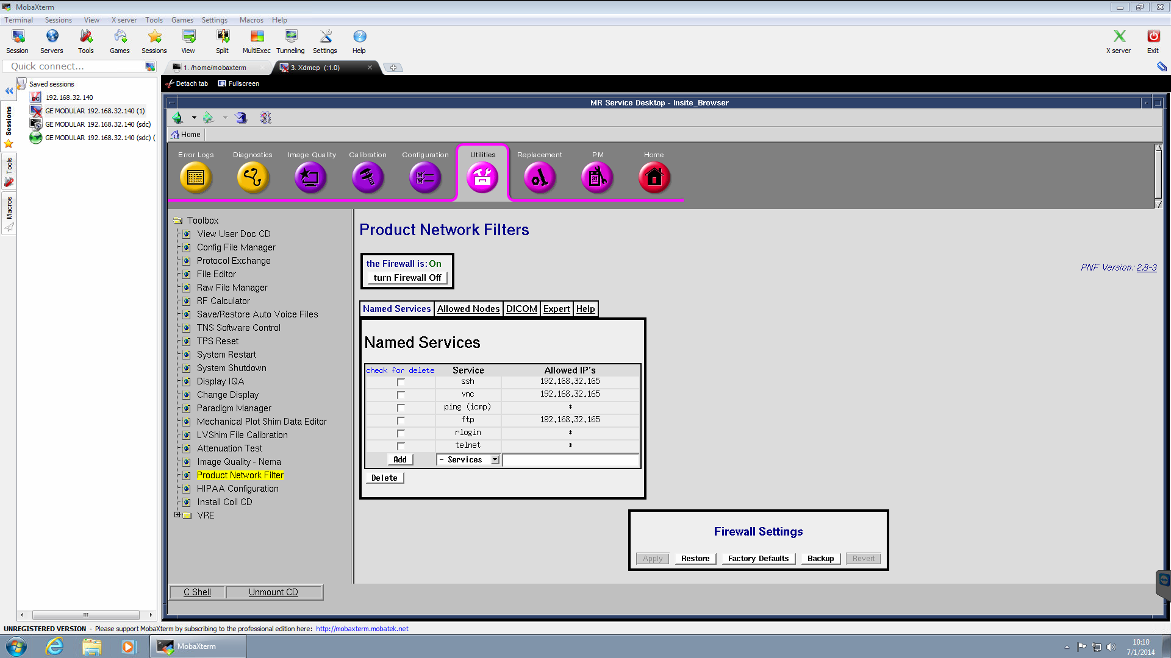

- IMPORTANT! After all the services have been added click apply (otherwise changes will not take effect)
- Navigate to Allowed Nodes and add the coldtrac ip address to the list making sure you click on apply changes when done as well.
- No system reboot is usually needed.
- Test the remote tools to make sure Coldtrac connects to the console.
